|  |  |  |  |  |  |  |  |  |  |  |  |  |  |  |  |
| --- | --- | --- | --- | --- | --- | --- | --- | --- | --- | --- | --- | --- | --- | --- | --- |
| ***Associe chaque personnage d’Halloween à sa définition*** | | | | | | | | | | | | | | | |
|  |  | | **Can't play in the sun or eat garlic** | | | | | |  |  | | |  | **Ghost** | |
|  |  | | **Can't see, speak or hear** | | | | | |  |  | | |  | **Bat** | |
|  |  | | **Can fly through walls and disappear** | | | | | |  |  | | |  | **Witch** | |
|  |  | | **Can sleep hanging upside down** | | | | | |  |  | | |  | **Werewolf** | |
|  |  | | **Can turn into a wolf once a month** | | | | | |  |  | | |  | **Mummy** | |
|  |  | | **Can cast spells and curses** | | | | | |  |  | | |  | **Vamire** | |
|  |  | | **Can be carved into faces** | | | | | |  |  | | |  | **Zombie** | |
|  |  | | **Can't eat real food (only brains)** | | | | | |  |  | | |  | **Pumpkin** | |
| ***Complète les phrases (rappel WHOSE =A qui ?)*** |  | |  |
| **1** | Whose _**_shirt**__ is this? | | | | | | | | | It's the zombie's | | | |  | |
| **2** | Whose _________________ is this? | | | | | | | | |  | | |  |  | |
| **3** | Whose coffin _________________? | | | | | | | | |  | | |  |  | |
| **4** | ______________ bandage is this? | | | | | | | | |  | | |  |  | |
| ***Ecris un petit poème en te servant de la première lettre pour commencer ta phrase*** | | | | | | | | | | | | | | |  | |  |
|  | | **Vampire** | | |  | Example | **B** | Bats are scary. | | | |  | | |  | |  |
|  | | **Werewolf** | | |  |  | **A** | A witch can fly. | | | |  | | |  | |  |
|  | | **Mummy** | | |  |  | **T** | The ghost can disappear. | | | | | | |  | |  |
|  | | **Zombie** | | |  |  |  |  | | |  |  | | |  | |  |
| |  | | --- | |  | | | ***1. Vas à la ligne pour chaque lettre*** | | | | | |  | | |  |  | | |  | |  |
|  | | ***2. Fais une phrase en anglais commencant par chaque lettre*** | | | | | | | | | | | | |  | |  |
|  | |  | | |  |  |  |  | | |  | |  | | --- | |  | | | |  | |  |

……………………………………………………………………………………………………………………………………………………………………………………………………………………………………………………………………………………………………………………………………………………………………………………………………………………………………………………………………………………………………………………………………………………………………………………………………………………………………………………

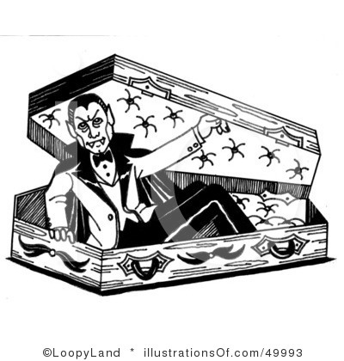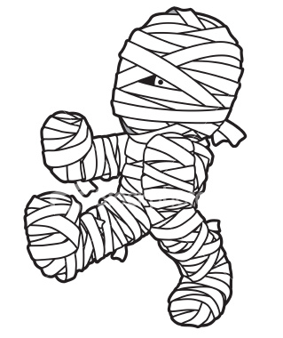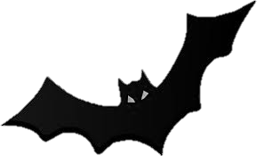

***Remets les lettres dans le bon ordre pour composer le nom des personnages.***

Gshto …………………………… veprmia ……………………….. ppmnuki………………………….

Bta …………………………………. Icnffo …………………………….. derpis ……………………………………

Cdsrae…………………………. Yoopks ………………………….. weehanllo ………………………

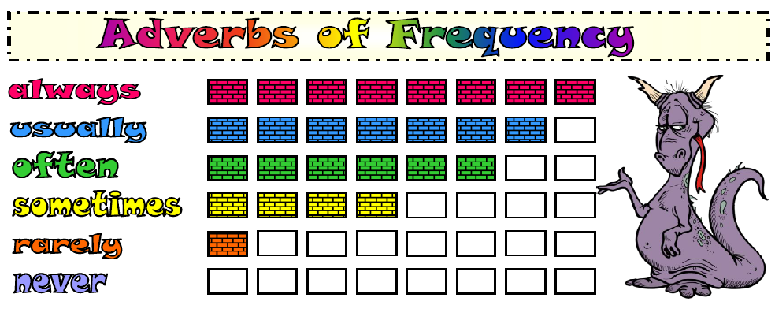

***Recopies les phrases en y ajoutant l’adverbe de fréquence (rappel : l’adverbe de fréquence se place AVANT le verbe). Soulignes les verbes en rouge et écris les adverbes en vert.***

1.Mr.Jones gets up at 6:30. (always)

............................................................................................................................................

2. She plays the flute. (sometimes)

............................................................................................................................................

3. I walk my dog in the park. (often)

..............................................................................................................................................

4. He reads an English story book. (rarely)

..............................................................................................................................................

5. Steve doesn't play computer games. (never)

...............................................................................................................................................

6. Claire goes to bed early. (always)

...............................................................................................................................................

7. Our dog doesn't eat spinach. (never)

...............................................................................................................................................

8. Mike swims in their swimming pool. (often)

……………………………………………………………………………………………………………………………………………

9. I eat my lunch in the cafeteria. (sometimes)

................................................................................................................................................

10. She walks to school. (usually)

................................................. …………………………………………………………………………………………..

***Remets les mots dans le bon ordre. Pense à la place de l’adverbe de fréquence dans la phrase !***

1. never / food / Julia / eats / fast

....................................................................................................................................................

2. play / they / sometimes / volleyball

...................................................................................................................................................

3. cat / milk / her / drinks / always

....................................................................................................................................................

4. walks / often / dad / work / my / to

....................................................................................................................................................

5. usually / makes / mum / a / cake / my

....................................................................................................................................................

6. social / I / study / rarely / sciences

....................................................................................................................................................

7. cheat / we / exams / never / the / in

………………………………………………………………………………………………………………………………………………………………