Collège Edmée Varin – Anglais – 3ème – continuité pédagogique du mardi 02 au vendredi 05 novembre 2021
Cette semaine nous travaillerons les différentes façons d’exprimer le conseil et la suggestion. Comme en classe, lis le point leçon avant de faire les exercices proposés.
Puis écris le titre sur ton cahier : Notion 2 : Le conseil et la suggestion, agrafe/colle ta feuille.
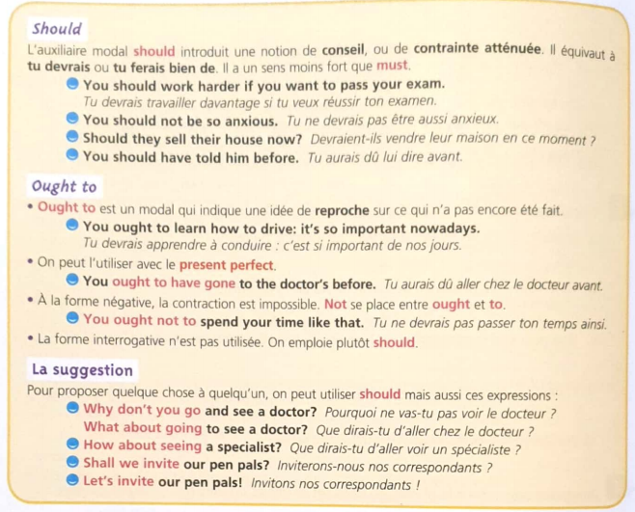
Activity 1 : Traduisez les phrases suivantes en employant Should
- Tu devrais écouter ton père. …………………………………………………………………………………
- Vous devriez voir ce film. …………………………………………………………………………………….
- Il devrait y avoir de la confiture dans le frigo. …………………………………………………………………
- Tu ne devrais pas toujours dire ce que tu penses tout haut. *………………………………………………
- Je trouves que nous devrions acheter un nouveau canapé. ………………………………………………
Activity 2 : Complète chaque phrase par la forme verbale qui convient :
- Michela should …………… more careful with her baby. (Be / been).
- She should have …………………….. to him before. (speak/spoken)
- I think we should ……………………. for him. (waited/wait)
- You should have …………….. me earlier. (tell / told)
- I ought to have …………………….. this fact a long time ago. (mention / mentioned)
Activity 3 : mettez ces phrases à la forme négative :
- She ought to clean her car. …………………………………………………………………
- Children ought to be heard. …………………………………………………………………
- There should be some sweets there. …………………………………………………………………
- Everyone should see that film. ………………………………………………………………………..
Activity 4 : Replacez les mots dans le bon ordre pour former une phrase cohérente :
- Should / ozone layer* / be / more / with / the / industrials / careful
…………………………………………………………………………………………………………………….
- Be / played / should / national anthem / every / match / the / before
…………………………………………………………………………………………………………………….
- Should / put / extra blanket* / an / bed / your / on / Winter / in / you
…………………………………………………………………………………………………………………….
When I was your man, Bruno Mars  Same bed but it feels just  A little bit ……………………….. now  Our song on the radio  But it don't sound the □ same □ fame  When our friends talk about you  All it does is just ………………+…….. +……………..  'Cause my heart breaks a little  When I hear your name  It all just sounds like (oooooh)  Hmmm too young too dumb to ………………….  that I..  ………………+ ……………+…………….. you flowers  And held your □ hand □ band  ……………..+…………….+…………….. you all my hours  When I had the □ dance □ chance  Take you to every party  'Cause all you wanted to do was …………..  Now my baby is dancing  But she's dancing with ……………….+………………..  My ………….., my ego, my needs and my ……………. ways  Caused the good strong woman like you to walk out my life  Now I never, never get to clean up …………+……………. I made  Ooh and it hunts me every time I close my eyes  It all just sounds like (oooooh)  Hmm too young too dumb to ………………..  that I  ………………+ ……………+…………….. you flowers  And held your □ hand □ band  ……………..+…………….+…………….. you all my hours  When I had the □ dance □ chance  Take you to every party  'Cause all you wanted to do was …………..  Now my baby is dancing  But she's dancing with ……………….+………………..  ……………………… it hurts  I'll be the first to □ sway □ say  That I was ……………………  Oooh I know I'm probably much too late  To try and ………………… for my ………………….  But I just want you to know  I hope he buys you flowers  I hope he holds your hand  Give you all his hours  When he has the chance  Take you to every party  'Cause I remember how much you loved to dance  Do all the things I ………………+…………….+………….  When I was your man  Do all the things I ……………… + ……………+ …………  When I was your man. | 1)Grâce à l’audio sur pronote, écoute cette chanson et  Retrouve les paroles, puis si tu veux une note bonus, traduis là sur feuille.  2)Réponds à ces questions en anglais :  Quel est le thème de cette chanson ? que raconte le chanteur ?  Amuse toi bien!

