Collège Edmée Varin, Anglais, 4ème, du lundi 25 au vendredi 29 octobre
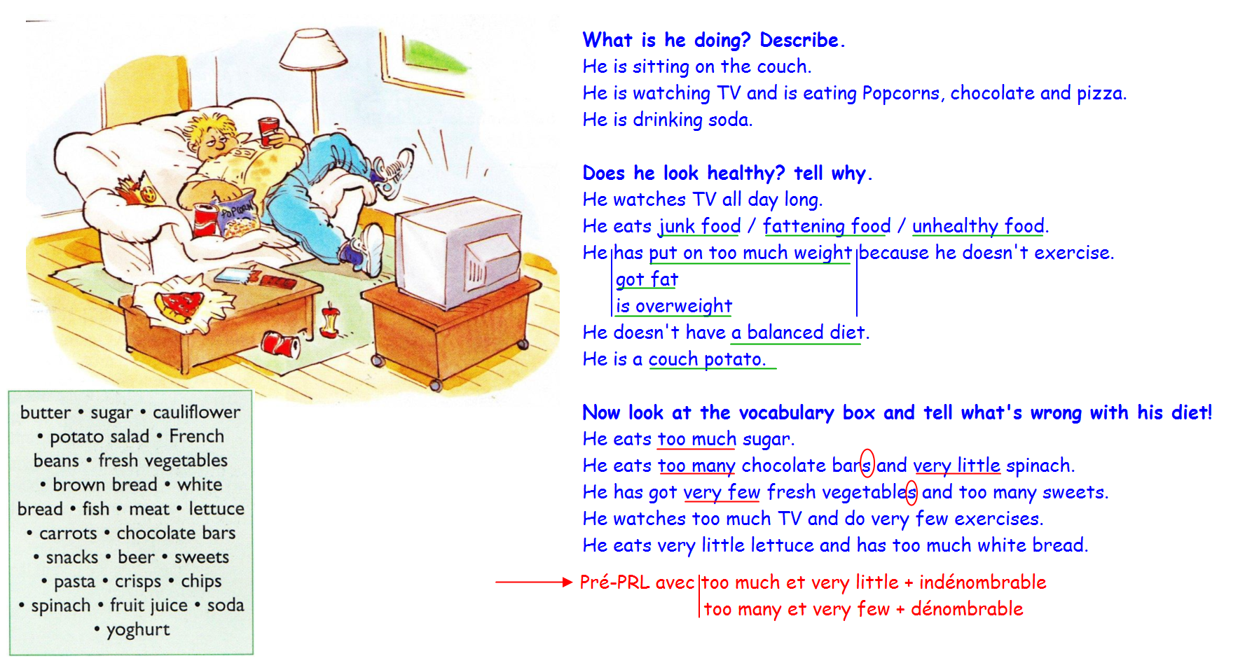
HEALTHY LIFE
- DON’T BECOME A COUCH POTATO
A/ Picture couch potato
* PRL : PRESENT SIMPLE / PRESENT BE + ING (fiche gram)
Don’t become a couch potato !

I can see a teenager who is eating snacks and drinking coke while he is sitting on the sofa and watching TV : he is a couch potato.

He is fat = overweight.
He has put on too much weight because he doesn’t exercise and
he eats fattening food
junk food
unhealthy food

He doesn’t eat healthy food.

His diet isn’t balanced so he isn’t in good health, he isn’t fit.

Conjugue le verbe « work » aux 2 présents.
Présent simple Présent be + ing
+ He_______________ every day. + Now he ______________________
- He___________________________ - He___________________________
? _______he_______________ ? ? _________he__________________ ?

Le présent simple s’emploie pour parler des________________________________________
Le présent be+ing s’emploie pour parler de _________________________________________
________________________________ou a une valeur de____________________________

Conjugue les verbes entre parenthèses au présent simple ou présent be + ing.
Souligne l’indicateur de temps dans chaque phrase.
- They never (go)______________________ to the cinema.
- Listen ! My brother (sing)___________________________
- I (not play)___________________________tennis today.
- She ‘s a teacher. She (teach)______________________English.
- (You / like)______________________________tea ?

B/ What’s wrong with his diet ?
* Unhealthy food
He eats too many / too much…
* Healthy food
He eats very few / very little / not enough…
 | Noms dénombrables  (countable) | Noms indénombrables (uncountable)
Unhealthy food  TROP | He eats TOO MANY biscuits  sweets  crisps  chips  He takes TOO MANY sweet or fizzy drinks. | He eats TOO MUCH pasta  pizza  butter  He drinks TOO MUCH lemonade, beer, soda, coke.
Healthy food  TRES PEU | He eats VERY FEW  apples  fresh vegetables  carrots  French beans | He eats VERY LITTLE  cauliflower  brown bread  fish  spinach  yoghurt  He drinks VERY LITTLE  plain water  fruit juice
PAS ASSEZ | He doesn’t eat enough vegetables or fish.

C/ PRL : QUANTIFIEURS
QUANTIFIEURS
 | Noms dénombrables pluriel | Noms indénombrables
combien  pas beaucoup  trop  tant !  peu  un peu  très peu | how many apples  not many people  too many  so many  few  a few  very few | how much time  not much money  too much  so much  little  a little  very little
Homework :
- Place les mots suivants dans le tableau selon qu’ils sont dénombrables ou indénombrables.
hour / time / year / snack / meat / water / subject / homework / money / dollar / friend / people.
Dénombrables (countable) | Indénombrables (uncountable)

- Complète les phrases avec « much / many / how much / how many / too much / too many / very little / very few. »
- _________________ sugar is there in a glass of coke ?
- I don’t like big cities because I think there is _________________ pollution.
- I haven’t got _______________ pocket money.
- Great ! We’ve got___________________ homework for tomorrow !
- Oh no ! The teacher gave us __________________ exercises !
- _________________ eggs do you need to make this cake ?
- _______________ teenagers enjoy listening to the radio.
- If you eat _________________ bread, _______________ potatoes and ______________ chocolate, you’ll have to go on a diet !

