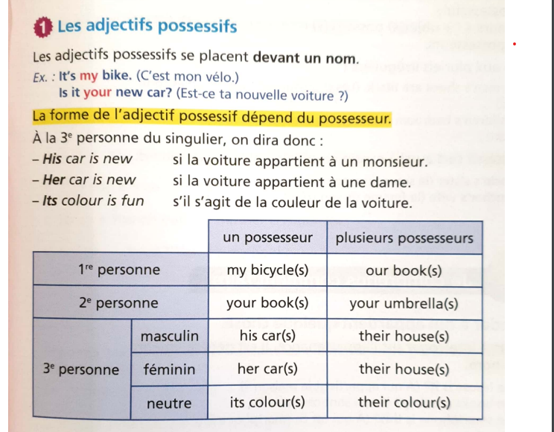

**ACTIVITY 1 Complète les phrases suivantes par he’s ou his.**

1. This boy is John……………….English but …………….father is American.
2. That man is a doctor. ……………………fifty-six.
3. Mr. Eliott is American. ………………car is very big.
4. Is Alex an English boy ? No, …………………..a French boy.

**ACTIVITY 2 Complète par l’adjectif possessif qui convient.**

1. Is that your tablet ? Yes, it’s ………………….tablet.
2. This boy is Irish. …………………………name is Mathew.
3. Sarah is French but ……………………mother is Algerian.
4. Is this ………………book ? Yes, it’s my book.

**ACTVITY 3 Réécris les phrases suivantes en remplaçant les expressions en gras par l’adjectif possessif correspondant.**

1. It’s John’s car. …………………………………………………………………………………………………………
2. It’s Jessica’s racket. ………………………………………………………………………………………………..
3. My parents are furious. My parent’s car is damaged. ……………………………………………..
4. Is your sister’s jacket new ? …………………………………………………………………………….........

**EXPRIMER LA POSSESSION AVEC HAVE GOT**

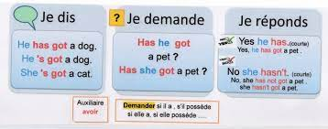

**ACTIVITY 1 Complète les phrases suivantes en conjuguant *have got.***

a. I …………………………………… a bike.

b. My father …………………………………….. a computer.

c. My parents ………………………. a new car.

d. We ……………………………………. a dog.

e. My uncle ……………………………. a boat.

**ACTIVITY 2 Mets chacune des phrases suivantes à la forme interrogative , puis négative.**

1. The Jones have got two children.

……………………………………………………………………………………………………………………………………………………………………………………………………………………………………………………………………………………………………………..

1. They’ve got a big car.

……………………………………………………………………………………………………………………………………………………………………………………………………………………………………………………………………………………………………………..

1. Helen has got a large dining room.

……………………………………………………………………………………………………………………………………………………………………………………………………………………………………………………………………………………………………………..

1. She’s got two fridges.

………………………………………………………………………………………………………………………………………………………………………………………………………………………………………………………………………………………………………………

1. My cousin’s cat has got green eyes.

………………………………………………………………………………………………………………………………………………………………………………………………………………………………………………………………………………………………………………

**ACTIVITY 3 Réécris les phrases suivantes en utilisant la forme contractée chaque fois que c’est possible.**

1. I have got a car and my brother has got one too.

……………………………………………………………………………………………………………………………………………….

1. We have got three bottles of juice in the fridge.

……………………………………………………………………………………………………………………………………………….

1. We have not got a bottle of milk.

………………………………………………………………………………………………………………………………………………..

1. Have you got a computer ?

………………………………………………………………………………………………………………………………………………..



1. ……………………………………….. 2. ………………………………… 3. ………………………..............

4. ………………………………………….. 5. …………………………………………. 6. ………………………

**ACTIVITY 4** Dis ce que tu as et ce que tu n’as pas dans ta chambre, utilise les mots de liaison « and », « but » et « too ». …………………………………………………………………………………………………………………………….